**1 The Basic HTTP GET/response interaction**

1.Is your browser running HTTP version 1.0 or 1.1? What version of HTTP is the server running?

Ans: HTTP Version 1.1

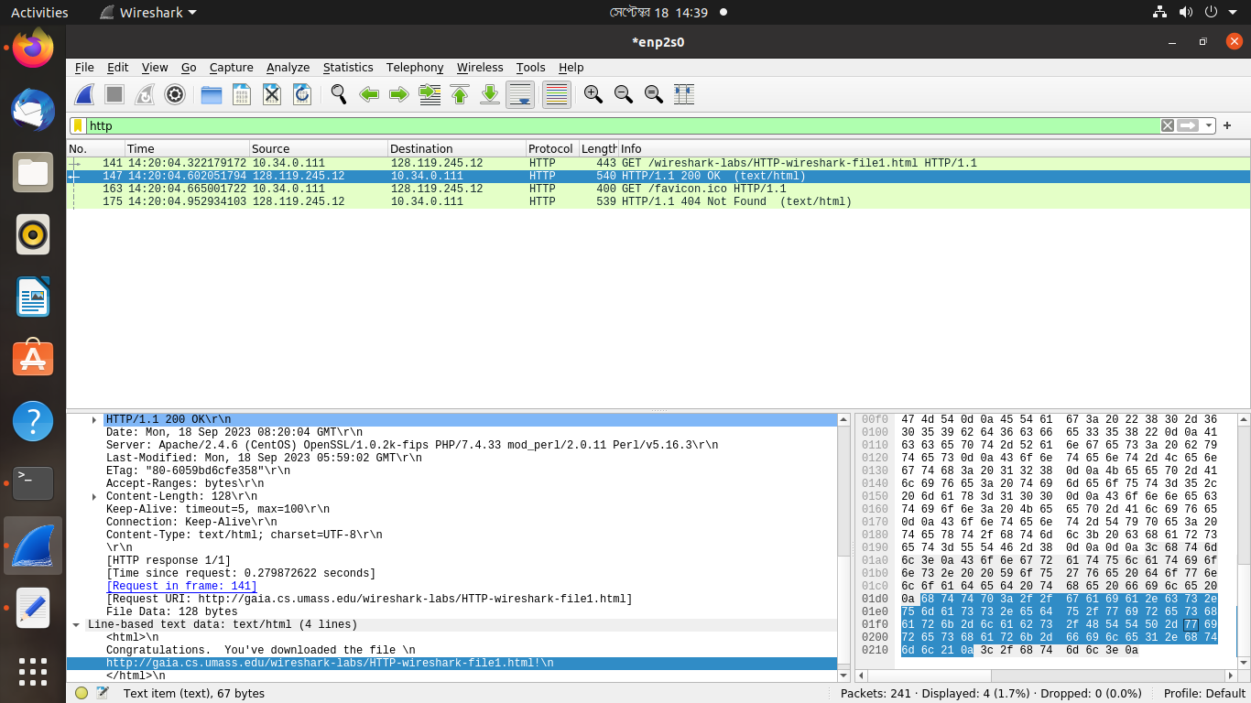

2. What languages (if any) does your browser indicate that it can accept to the server?

Ans: Accepting Language:en-US

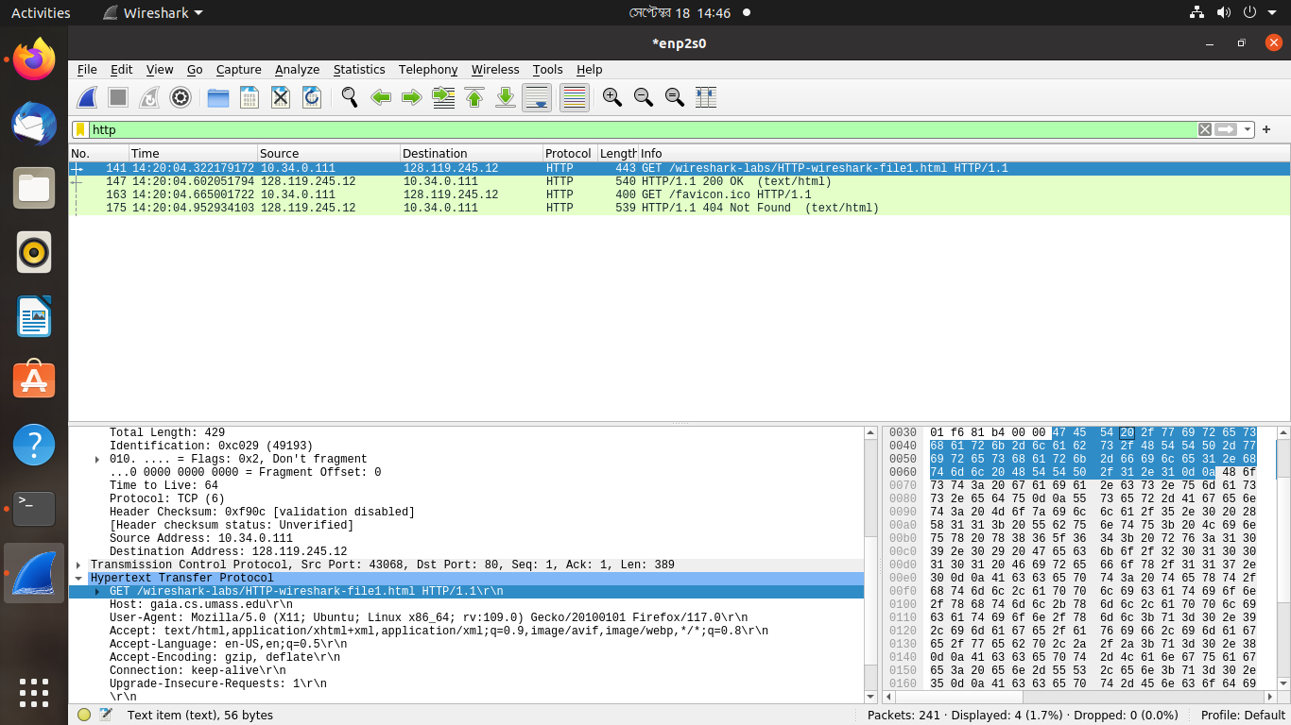

3. What is the IP address of your computer? Of the gaia.cs.umass.edu server?

Ans: My IP Address-10.34.0.111

gaia.cs.umass.edu server-128.119.245.12



4. What is the status code returned from the server to your browser?

Ans: Status Code-200

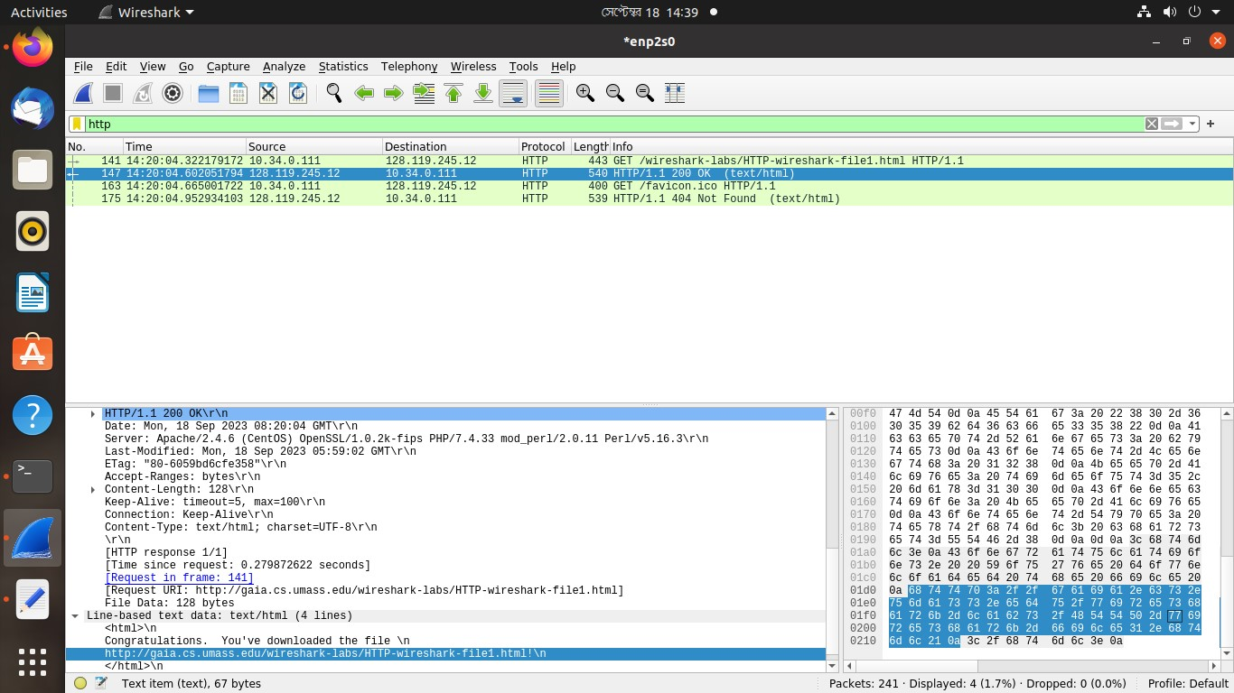

5. When was the HTML file that you are retrieving last modified at the server?

Ans: Last-Modified: Mon, 18 Sep 2023 05:59:02 GMT\r\n



6. How many bytes of content are being returned to your browser?

Ans: 128 bytes



7. By inspecting the raw data in the packet content window, do you see any headers within the data that are not displayed in the packet-listing window? If so, name one.

Ans:

**2 The HTTP CONDITIONAL GET/response interaction**

8. Inspect the contents of the first HTTP GET request from your browser to the server. Do you see an “IF-MODIFIED-SINCE” line in the HTTP GET?

Ans: No.

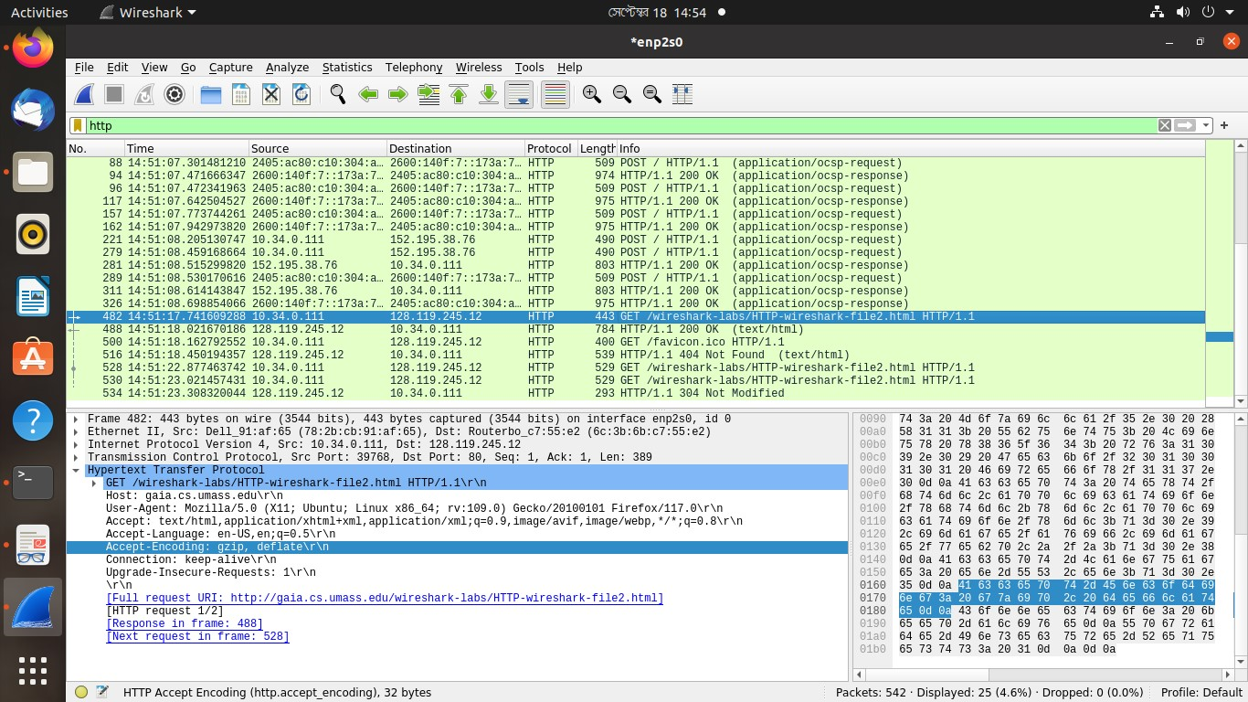

9. Inspect the contents of the server response. Did the server explicitly return the contents of the file? How can you tell?

Ans: Yes, it explicitly returned the contents of the file cause there is "OK" and status code with it.

10. Now inspect the contents of the second HTTP GET request from your browser to the server. Do you see an “IF-MODIFIED-SINCE:” line in the HTTP GET? If so, what information follows the “IF-MODIFIED-SINCE:” header?

Ans: Yes. Information followed by the "IF-MODIFIED-SINCE:" header-

If-Modified-Since: Mon, 18 Sep 2023 05:59:02 GMT\r\n

If-None-Match: "173-6059bd6cfd7a0"\r\n

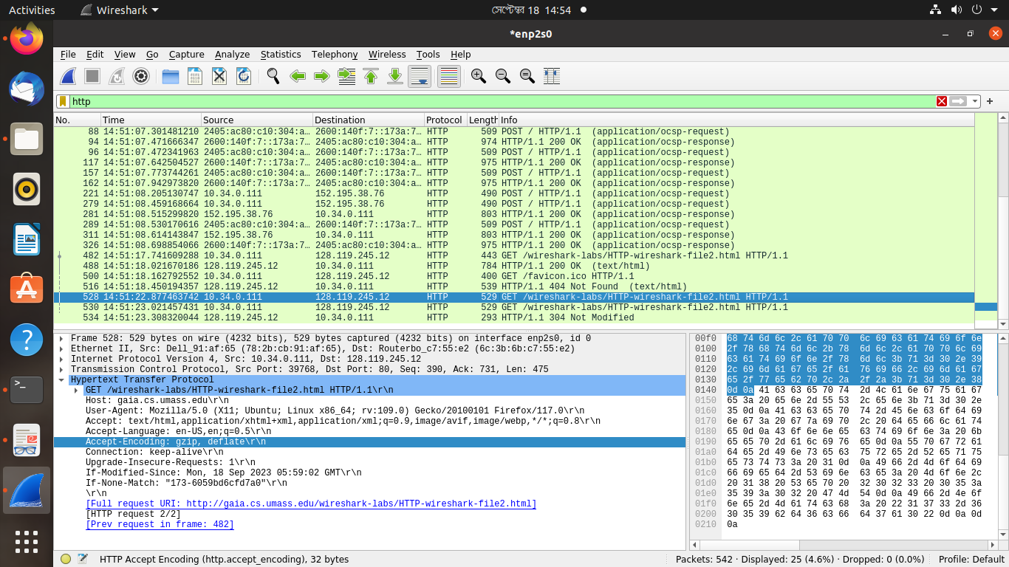

11. What is the HTTP status code and phrase returned from the server in response to this second HTTP GET? Did the server explicitly return the contents of the file? Explain.

Ans: No, it didn’t explicitly return the contents of the file

**3 Retrieving Long Documents**

12. How many HTTP GET request messages did your browser send? Which packet number in the trace contains the GET message for the Bill or Rights?

Ans: Two, Packet Number-25

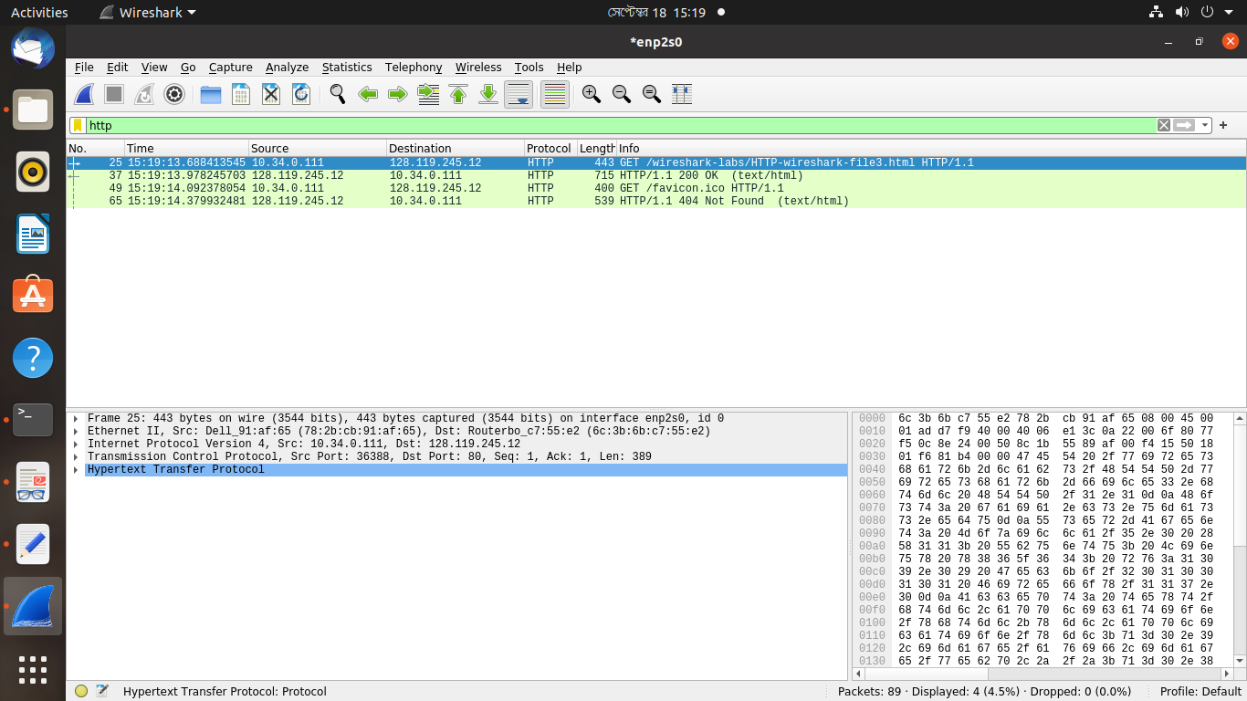

13. Which packet number in the trace contains the status code and phrase associated with the response to the HTTP GET request?

Ans: Packet Number-37

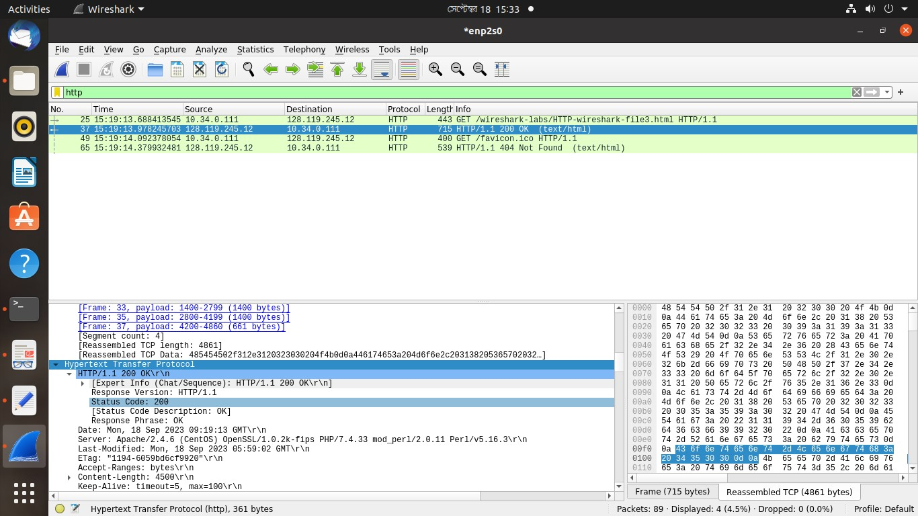

14. What is the status code and phrase in the response?

Ans: Status Code: 200 | Response Phrase: OK



15. How many data-containing TCP segments were needed to carry the single HTTP response and the text of the Bill of Rights?

Ans: 4 TCP segments were needed.

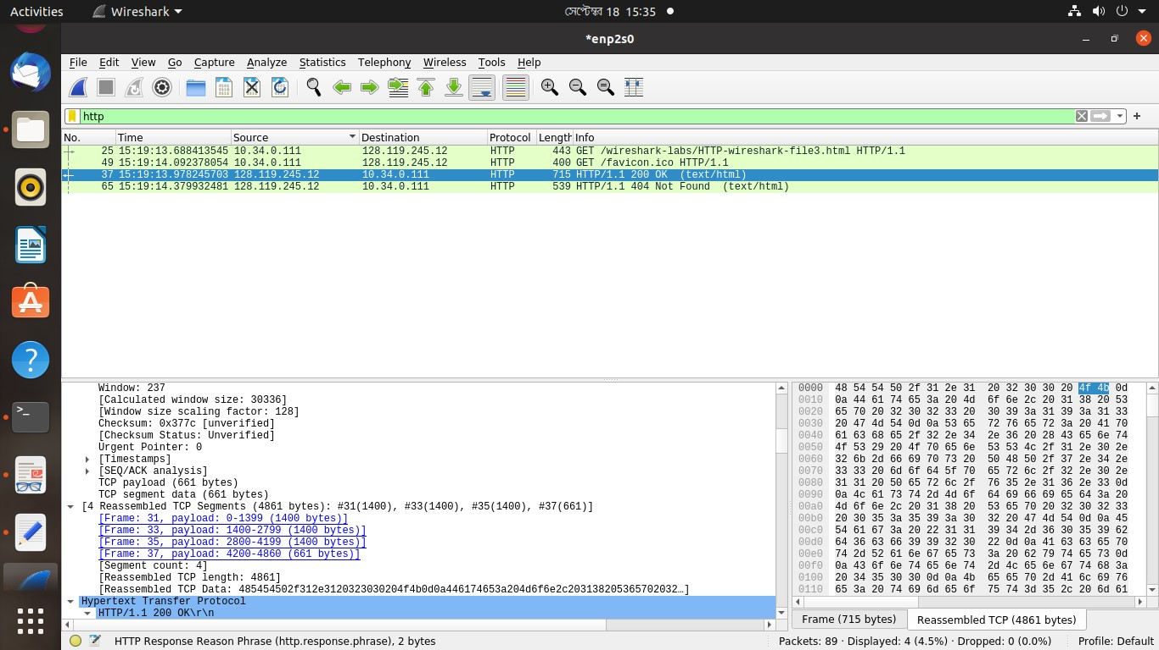

**4 HTML Documents with Embedded Objects**

16. How many HTTP GET request messages did your browser send? To which Internet addresses were these GET requests sent?

Ans: 4 HTTP GET request messages. Host: gaia.cs.umass.edu\r\n

Destination IP Address: 128.119.245.12

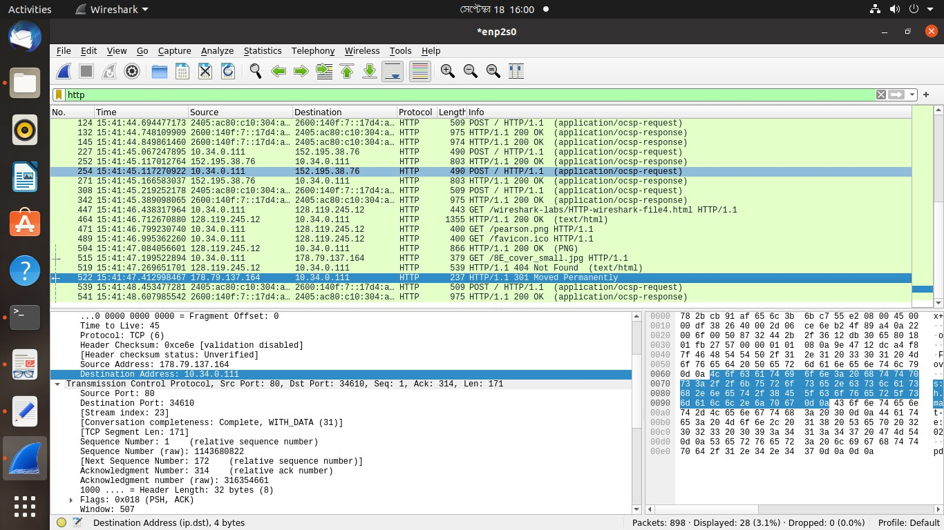

17. Can you tell whether your browser downloaded the two images serially, or whether they were downloaded from the two web sites in parallel? Explain.

Ans: My browser downloaded the two images serially because after we requested the first get for the first image, we got the ok and then we requested another get for the second image.

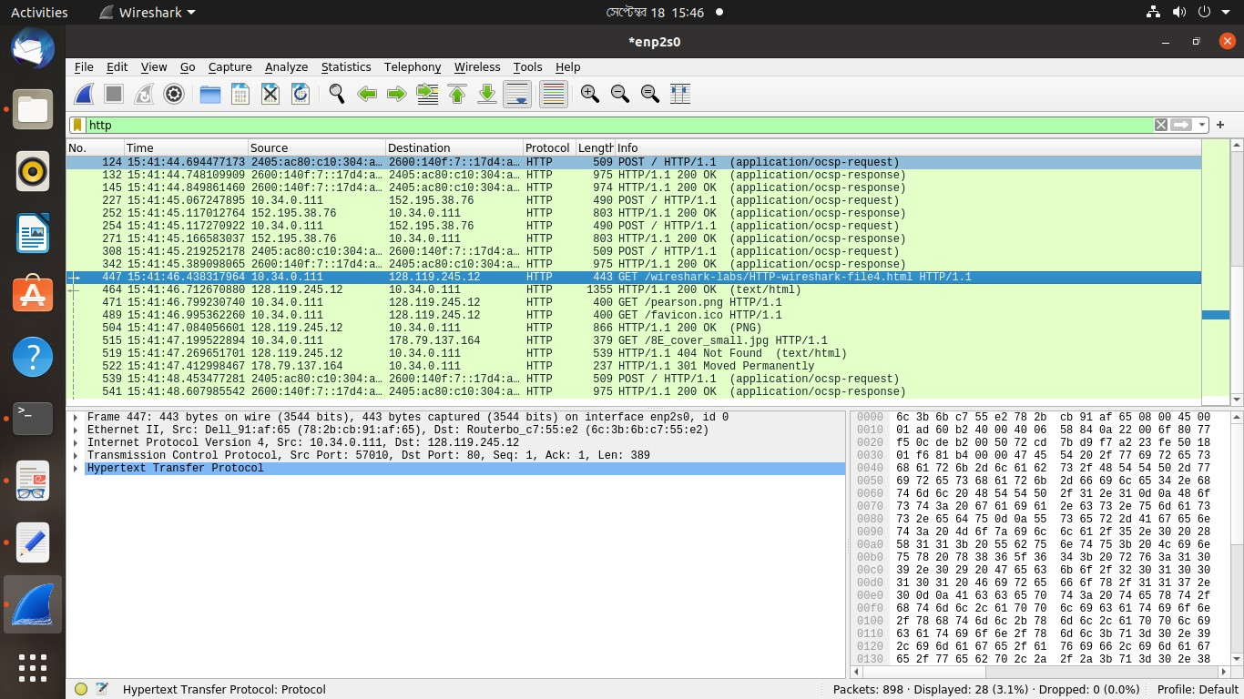

**5 HTTP Authentication**

18. What is the server’s response (status code and phrase) in response to the initial HTTP GET message from your browser?

Ans: Status Code: 401 | Response Phrase: Unauthorized

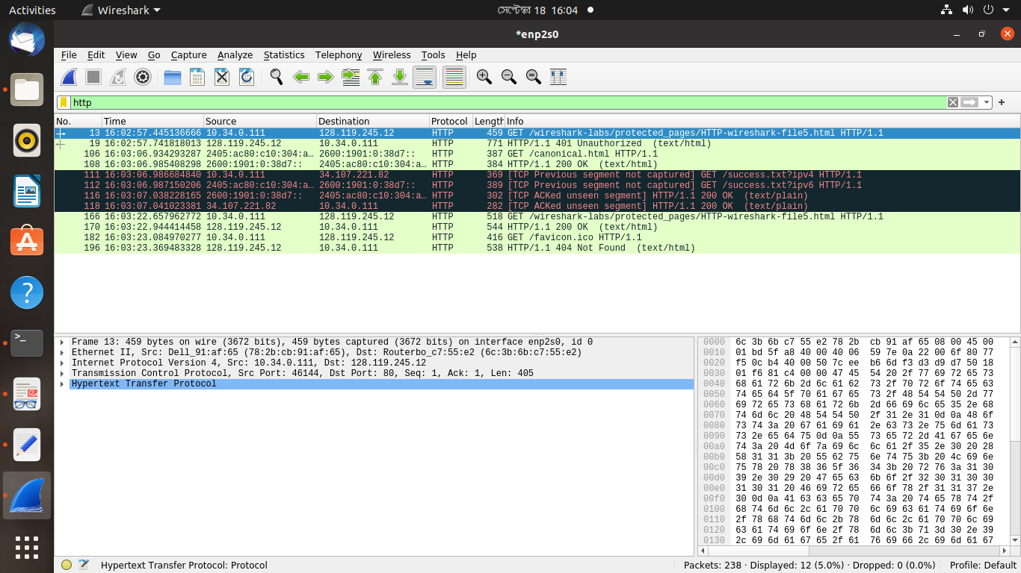

19. When your browser’s sends the HTTP GET message for the second time, what new field is included in the HTTP GET message?

Ans: Authorization: which includes username and password

